WORKSHEET

TOPICS: MAGNETIC EFFECT OF ELECTRIC CURRENT

SECTION-A ( ONE MARK QUESTIONS )

- Write the frequency of alternating current (AC) in India. How many times per second it changes its direction?
- Why are the magnetic field lines closed curves ?
- Where do we connect a fuse with live wire or with neutral wire?
- State the colour convention used for live, neutral and earth wires used in domestic electric circuits.
- State one advantage of A.C over D.C.
- State the right hand thumb rule ?
- State the rule that determines the direction of magnetic field due to a current carrying straight conductor.
- A positively charged particle projected towards west is deflected towards north by a magnetic field. State the direction of magnetic field.
- Give one application of electromagnetic induction.
- What does the thumb indicated in Fleming’s right hand rule ?
- State the direction of magnetic field in the following case-
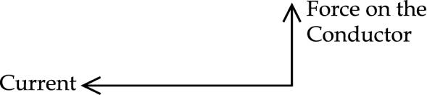
- State the use of earth wire in domestic electric ciruit.
- State the condition under which an electron moving though a magnetic field with a given speed experiences maximum force.
- What does the degree of closeness of magnetic field lines near the poles signify?
- The magnetic field in a given region is uniform. Draw a diagram to represent it.
- State the observation made by oersted on the basis of his experiment with current carrying conductors ?

SECTION-B ( TWO MARKS QUESTIONS )

- Draw magnetic field lines around a bar magnet. Name the device which is used to draw magnetic field lines.
- Name and state the rule to determine the direction of a force experienced by a current carrying straight conductor placed in a magnetic field which is perpendicular to it. Name a device that uses current carrying conductor and magnetic field.
- Draw a pattern of magnetic field lines around a straight conductor carrying electric current. How this magnetic field be affected on
(a) Increasing the current through the conductor?
(b) Reversing the direction of flow of current in the conductor?
4. State right hand thumb rule to find the direction of the magnetic field around a current – carrying straight conductor. Show by drawing a diagram.
5. A student performs an experiment to study the magnetic effect of current around a current carrying straight conductor. He reports that (i) the direction of deflection of the north pole of a compass needle kept at a given point near the conductor remains unaffected even when the terminals of the battery sending current in the wire are inter – changed.
(ii) (ii) for a given battery the degree of deflection of a N-pole decreases when the compass is kept at a point further away from the conductor. Which of the above observation of the student is incorrect and why ?
6. What is an electric fuse? State it’s function in an electric circuit.
7. What happens to the force acting on current carrying conductor placed in magnetic field when :
(a) Current in conductor increases.
(b) Length of the conductor increase.
(c) Direction of the current and magnetic field both are reversed.
(d) Direction of the current is reversed without changing the direction of magnetic field.
8. What is induced current ? state the rule used to find the direction of induced current.
9. List four factors on which the magnitude of force acting on a current carrying conductor in a magnetic field depends.
10. How is an electromagnet made ?
11. Name and explain the rule used to determine the direction of current induced in a coil due to its rotation in a magnetic field.
12. Magnetic field lines of two magnets are shown in fig A and fig B. select the figure that represents the correct pattern of field lines. Give reasons for your answer. Also name the poles of the magnets facing each other.
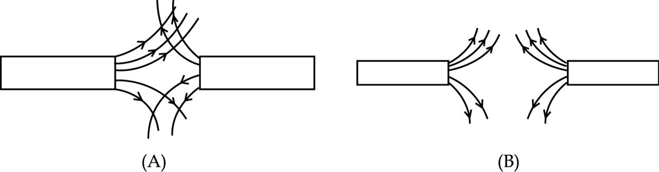
13. Name the type of electric current generated by most of the power stations in our country. Why is it preferred over the other type of electric current ? State the frequency of power supply generated in India.
14. AB is a thick copper wire. When electric current „I‟ flows through the wire, what change is observed in the compass needle placed near the wire? Give reason for this observation. State the change that would be observed if the direction of electric current in the wire is reversed.
15. Magnetic field lines around a bar magnet are as shown. Ram makes a statement that magnetic field at point „A‟ is stronger than at point „B‟. State whether Ram is correct ? Justify your answer.
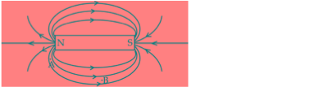
A coil of insulated copper wire is connected to a golvanomenter as shown in the diagram. State your observations when a bar magnet is

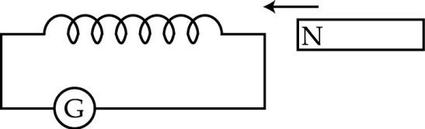

(i) Pushed into the coil with its north pole entering first.
(ii)Held at rest inside the coil.
Name the phenomenon responsible for the above observation.

SECTION-C ( THREE MARKS QUESTIONS )

1. (a) State Right Hand Thumb rule to find the direction of the magnetic field around a current carrying straight conductor.
(b) How will the magnetic field be affected on :
(i) increasing the current through the conductor
(ii) reversing the direction of flow of current in the conductor.
2. In the arrangement shown in figure, there are two coils A and B wound on non – conducting cylindrical rod ? Initially the Key is not inserted.
Then the Key is inserted and later removed.
(i) State your observation in each case ?
(ii) State the conclusion based on your observations ?
(iii) Name the phenomenon and define it.
(iv) Name the two coils.
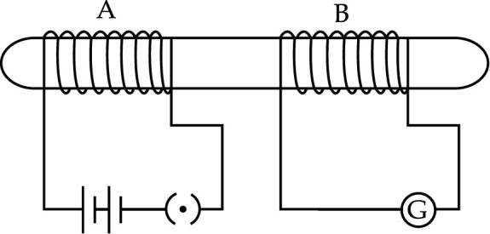
3. What happens if a domestic electric circuit is short circuited? An electric iron of rating 1000w; 220v is to be operated in a 220V electric circuit in which an electric fuse of 3A rating is connected. What is likely to happen when the electric iron operates? Justify your answer.
- What potential difference is maintained between the live wire and the neutral wire in our domestic electric supply ? The main power supply of a house is through a 5 A fuse. How many 100 W bulbs can be used in this house at the correct voltage ?
- Why does a current carrying conductor kept in a magnetic field experience force ? List the factors on which the direction of this force depend. Name and state the rule used for the determination of direction of this force.
- A galvanometer is connected to a coil of insulated copper wire.
What will happen if a bar magnet is :
- inserted into the coil.
- withdrawn from inside the coil.
- held stationary inside the coil.
- What is a fuse. State its function. An electric oven of 2KW power is operated in a domestic electric circuit of 220 V that has a current rating of 5A. What result do you expect? Justify your answer.
- Write one application of each of the following :-
a. Right hand thumb rule
b. Fleming’s left hand rule
c. Fleming’s right hand rule
9. What is ‘overloading’ of an electric circuit ? State two conditions that can lead to overloading of a circuit. How can it to be prevented ?
10. Name the three types of wires used in household circuits. Out of these three which wire is used as a safety measure especially for those appliances that have metallic body. State the colour of insulation used for this wire. How it ensures the safety of the user ?
11. An electric motor of 3kW power rating is operated in a domestic electric circuit (220 V) that has a current rating of 5 A. What is likely to happen when electric current is passed through the motor ? Justify your answer.
12. Name two electrical appliances of daily use in which electric motor is used. Name and state the principle on which an electric motor works.
SECTION-D ( FIVE MARKS QUESTIONS )
- What is a solenoid ? Draw a diagram to show field lines of the magnetic field through and around a current carrying solenoid. State the use of magnetic field produced inside a solenoid. List two properties of magnetic lines of force.
- Write the values of the following physical quantities in connection with domestic power supply in our country (
(ii)
(a) potential difference between live wire and neutral wire (b) frequency of A.C
Explain the role of the following as safety measure in domestic electric appliances/circuits(a) earth wire (b) fuse .
- What is a solenoid ? The magnetic field lines inside a solenoid are in the form of equidistant parallel straight lines. What does this signify ? How is electromagnet formed ? Draw a diagram to show the field lines of the magnetic field through and around a current carrying solenoid.
- (i) What is an electromagnet
(ii) Name the material which can be used to make –
  - (a) Permanent magnet
  - (b) Temporary magnet.
(iii) State two ways by which the strength of an electromagnet can be increased.
(iv) What is the purpose of soft iron core used in making an electromagnet.
5. (a) State the rule to determine the direction of a
(i) force experienced by a current carrying straight conductor placed in magnetic field which is perpendicular to it and
(ii) current induced in a coil due to its rotation in a magnetic field.
(b) What is a solenoid? Draw magnetic field lines due to a current carrying solenoid.
6. (a) Draw a schematic labelled diagram of a domestic wiring circuit which includes
(i) a main fuse (ii) a power meter
(iii) one light point and a (iv) power plug (b) State the importance of connecting an earth wire to electric appliances having metallic covers?
7. (a) What are magnetic field lines ? Why two magnetic field lines cannot intersect each other ?
(b) Show experimentally that change in current flowing through a coil causes an induced potential difference in a neighbouring coil. Name the process involved.
8. What is electromagnetic induction ? State different ways of inducing current in a coil. Suggest the most convenient situation for inducing current in a coil. State the situation in which the induced current in the coil is found to be the highest.
9. Define a magnetic field line. Two field lines cannot intersect each other why ? Draw the pattern of magnetic field lines for a current carrying circular loop. On what factors magnetic field at the centre of current carrying circular loop depends ?
10. Describe an activity to show the phenomenon of electromagnetic induction. Name and state the rule to determine the direction of induced current produced in a conductor.
11. Describe an activity to show that induced current can be produced in one coil on changing current in another coil placed near it. State the rule to determine the direction of induced current in a conductor.
12. What is short circuiting ? List two precautions to prevent it. What is the colour of insulation of earth wire ? State its function in a domestic circuit and explain how earthing of an electric appliance saves him from a severe electric shock.
13. (a) Draw a schematic diagram of a common domestic circuit.
(b) Explain the function of fuse and earth wire.
(c) Write two precautions that should be taken to avoid short circuiting.
14. (a) Explain Fleming’s left hand rule.
(b) Describe an activity to show the force experienced by a current-carrying conductor placed in a magnetic field.
15. (a) What happens to the force experienced by a current carrying conductor placed in a uniform magnetic field, when placed
  - (i) parallel to magnetic field ?
  - (ii) perpendicular to magnetic field ?
(b) State Flemings left hand rule. Use it to find the direction of magnetic field in the following case.
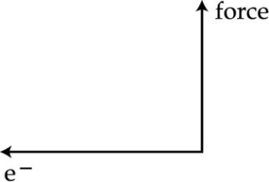

16. Draw a schematic diagram of a common domestic circuit showing live wire, neutral wire and the earth wire. List four characteristic features of circuits used in residential buildings.
17. Describe an activity to explain how a moving magnet can be used to generate electric currents. List two practices of inducing current in a coil. Which one of the two is more convenient in most situations? Name the process of inducing current in this manner.
18. Draw the pattern of magnetic field lines through and around a current carrying loop. Mark the directions of (i) electric current flowing through the loop (ii) magnetic field lines. How would the strength of magnetic field due to a current carrying loop he affected if :
(a) the radius the loop is reduced to half of original value, and
(b) the strength of the current through the loop is doubled ?
19. (i) Describe an activity to show how a moving magnet may be used to generate an electric current. State the rule to find the direction of electric current generated in the coil.
(ii) A coil ‘A’ of insulated copper wire is connected to a galvanometer. What would you observe when
(a) a current carrying coil ‘B’ is brought near ‘A’ ?
(b) strength of current in coil ‘B’ is changed ?
(c) name the process of generating current in the coil in this manner.
20. Two coils C1 and C2 are wrapped around a non conducting cylinder. Coil C1 is connected to a battery and key and C2 with galvanometer G. On pressing the key (K), current starts flowing in the coil C1. State your observation in the galvanometer :
(i) When key K is pressed on.
(ii) When current in the coil C1 is switched off.
(iii) When the current is passed continuously through coil C1.
(iv) Name and state the phenomenon responsible for the above observation.
Write the name of the rule that is used to determine the direction of current produced in the phenomena.
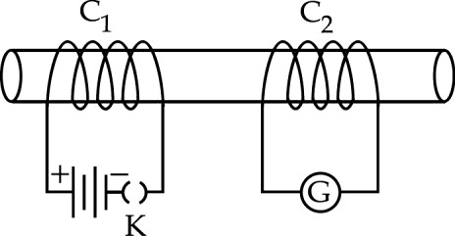
21. (i) The given figure shows a domestic electric circuit. Study this circuit carefully. List any two errors in the circuit and justify your answer.
(ii) Give one difference between the wires used in the element of an electric heater and in a fuse.
(iii) List two advantages of parallel connection over series connections.
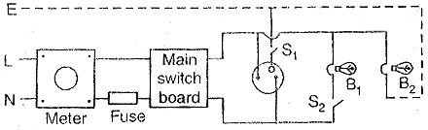
22.
Observe the figure given below and answer the following questions – a) Write the special name given to the coil AB which has many circular turns of insulated copper wire.
b) State the nature of magnetic field inside AB when a current is passed through it.
(c) Re-draw the diagram and sketch the pattern of magnetic field lines through and around AB.
(d) List two factors on which the strength of the magnetic field produced by AB depends.
(e) What is the effect of placing an iron core in the coil AB?


